**Automate an E-Commerce Web Application**

**All Test Case Passed**

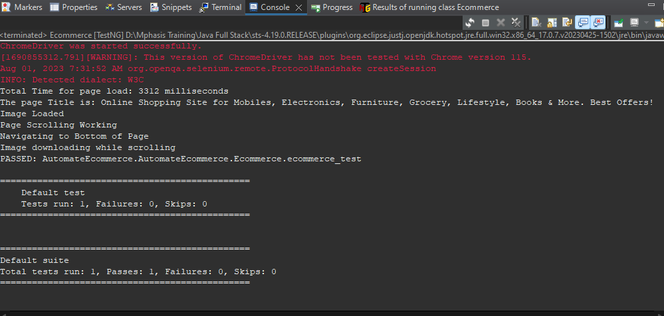

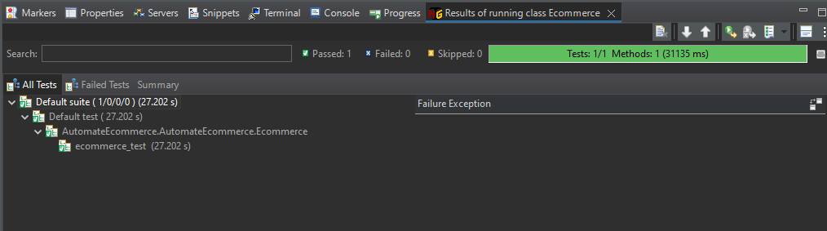

**Test Report**

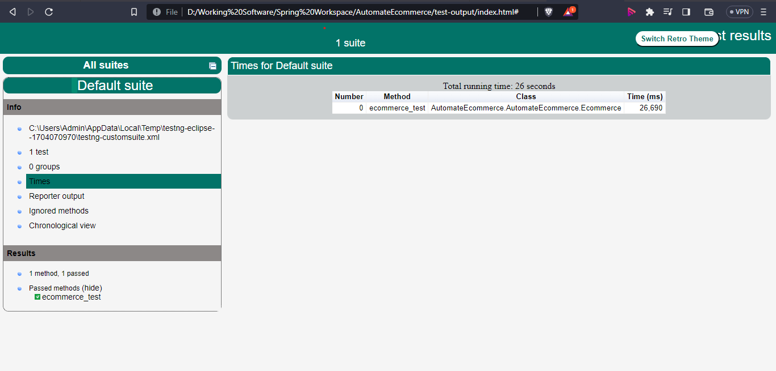

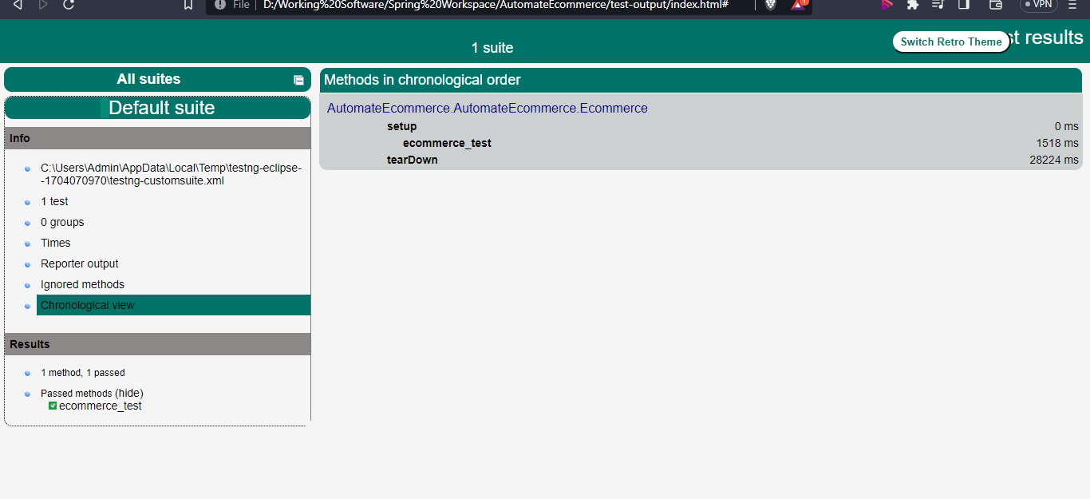

**Emailable Report**

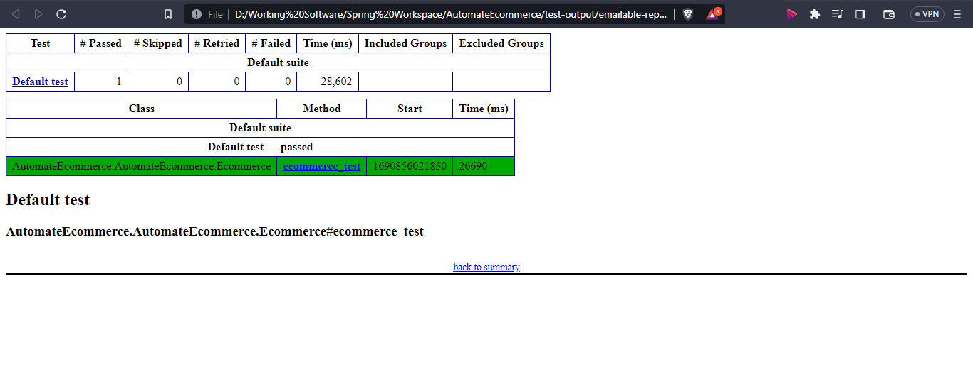

**FilpCart Output**

Opening the flipkart home page and searching for Iphone 13

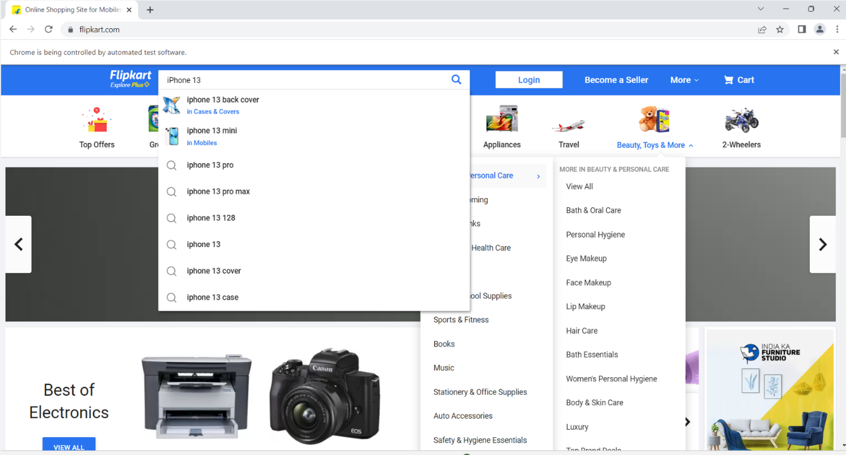

After entering click on search button and after the page loads checking the first image of Iphone is loaded

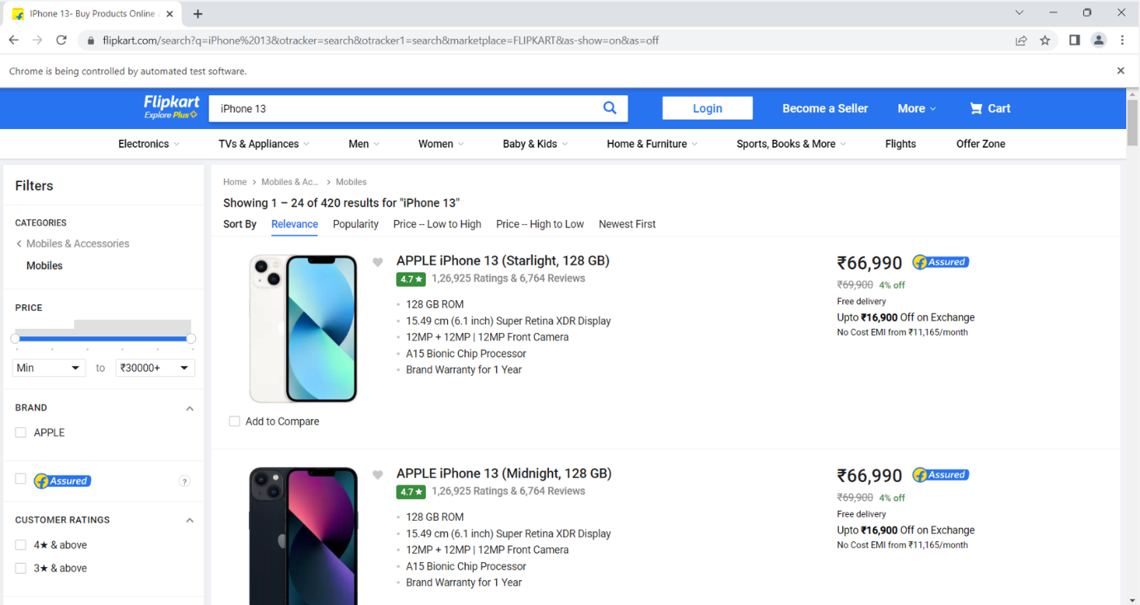

Check for scrolling and scrolling 500px down

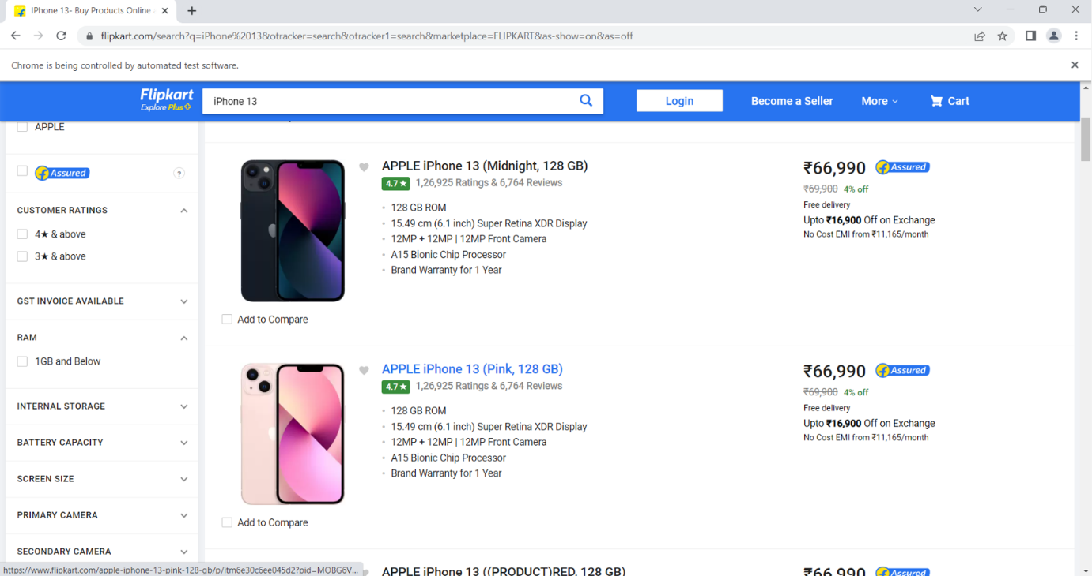

Going to the bottom of the page

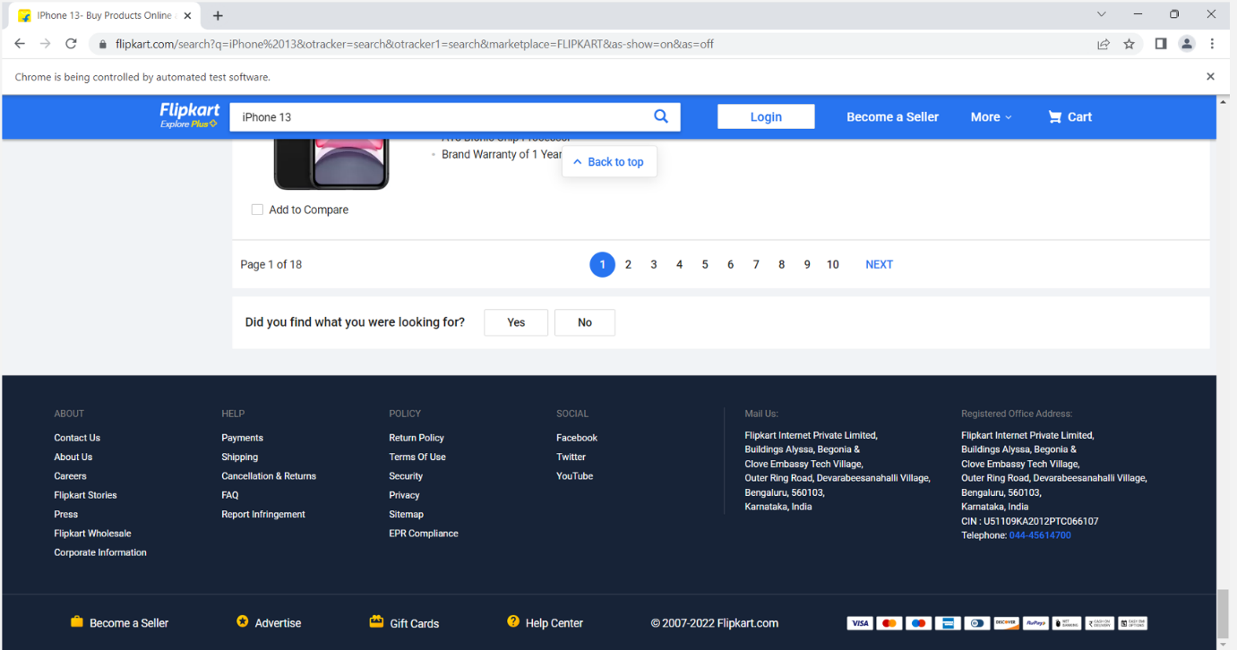

From bottom scroll up 500px and check whether the images are loaded

While scrolling

